# Module – 6 CloudWatch logs

**Assignment 3 : To create an alarm to reboot an instance and recover an instance (Amazon EC2 console)**

To receive the alarm notification, we created notification topic and below are the steps

Step 1: Go to SNS service and create a ‘Topic’



Step 2: Configure below properties to create a ‘Topic’

1. Type: Select ‘Standard’
2. Topic Name: ‘m6assignment_alarm

Click on **‘Create topic’**.

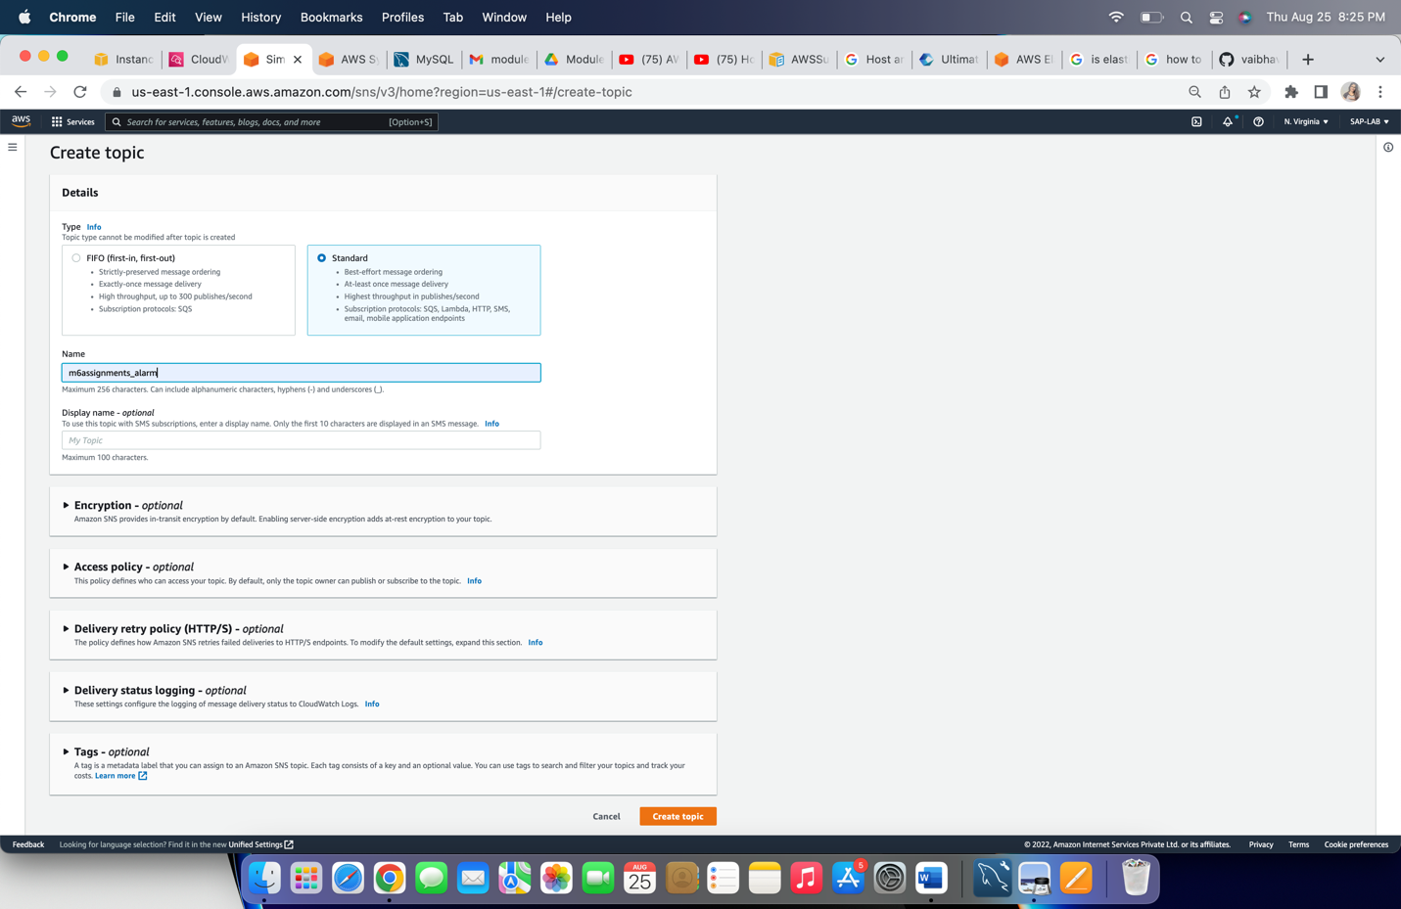

Step 3: click on **Create subscription**

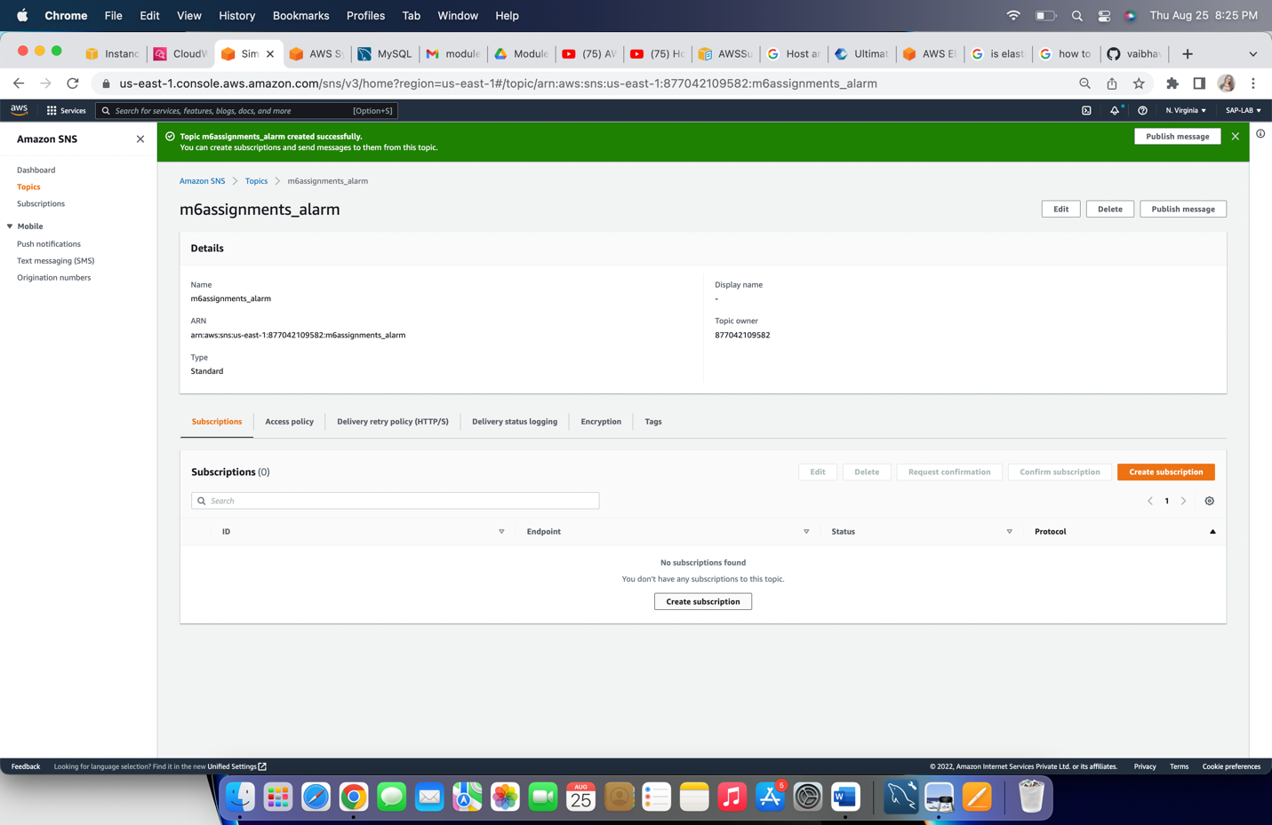

Step 4: Configure below properties to create ‘subscription’

1. Topic arn: Choose the topic arn
2. Protocol: Select ‘Email’
3. Endpoint: put the email to receive notification

Click on ‘Create Subscription’

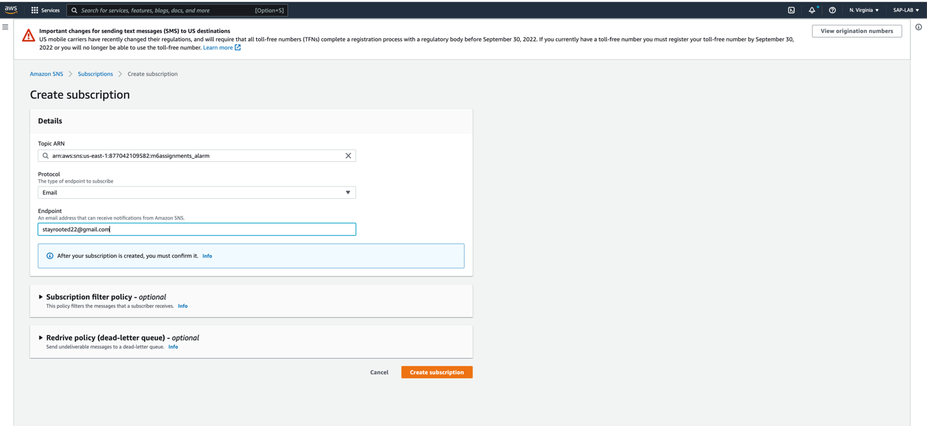

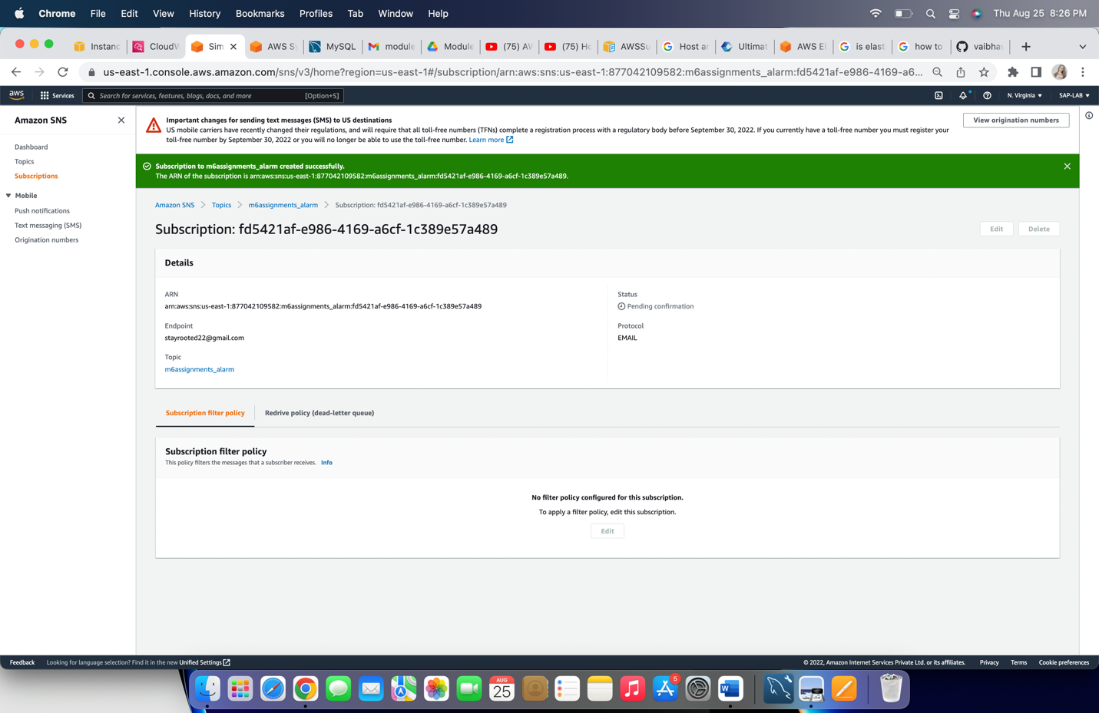

In the above snap, status is ‘Pending confirmation’, to confirm the subscription go to your mail account and confirm through received confirmation mail.

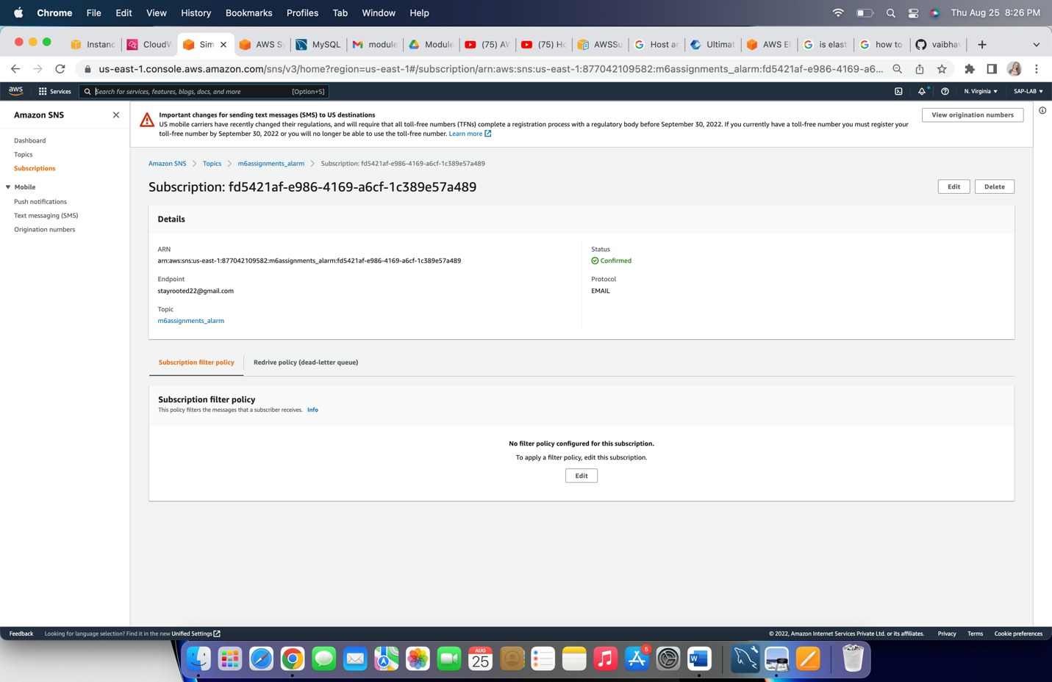

Step 5: Select instance, click on ‘Actions’ then ‘CloudWatch monitoring’ and click on ‘Add/Edit Alarm’.

1. ‘create alarm’
2. Put the name of ‘Topic’, to **‘Send a notification to’**
3. Put email for sending notification in **‘With these recipients’**
4. Select action for ‘Take the action’ – ‘Reboot the instance’
5. Put the threshold limit, **Whenever**
   1. **Avg pf CPU utilization increases/decrease usage percentage.**
6. Define number for consecutive periods of CPU utilization.
7. Put name of alarm.
8. Click on ‘**Create Alarm**’

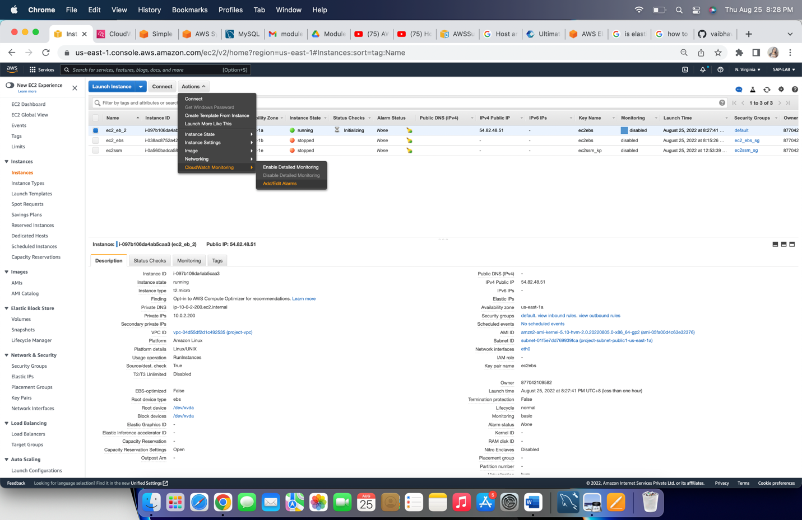

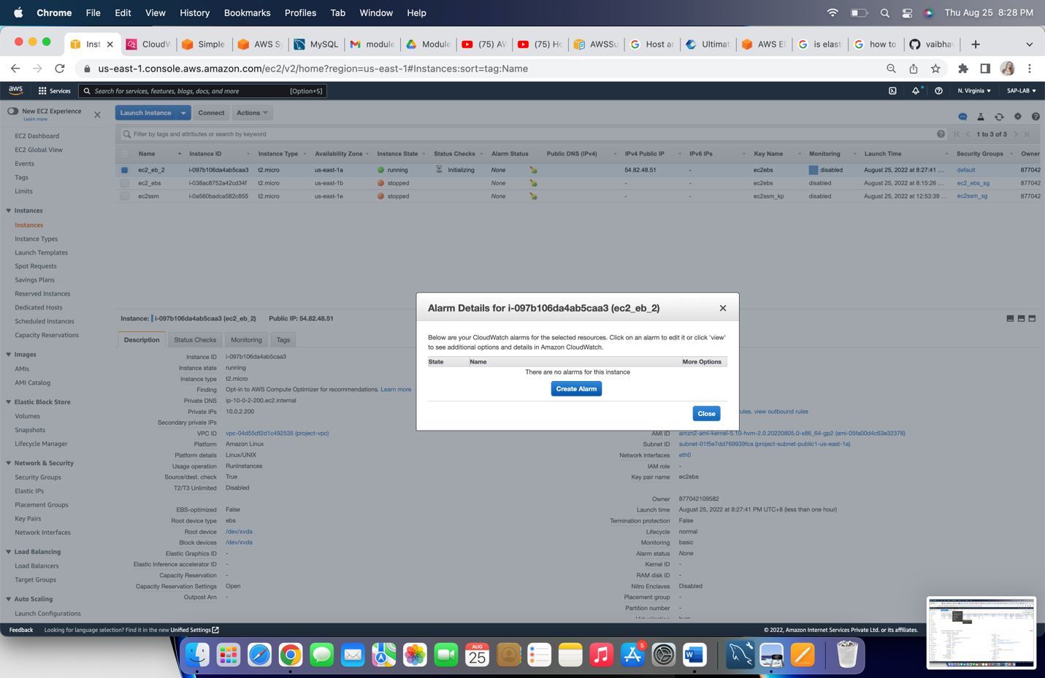

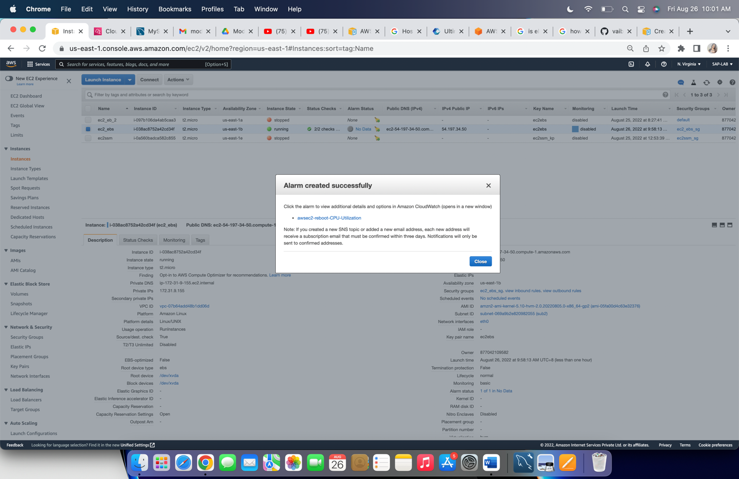

When threshold will reach the limit, alarm will be activated and action will be enabled and instance will get reboot.

